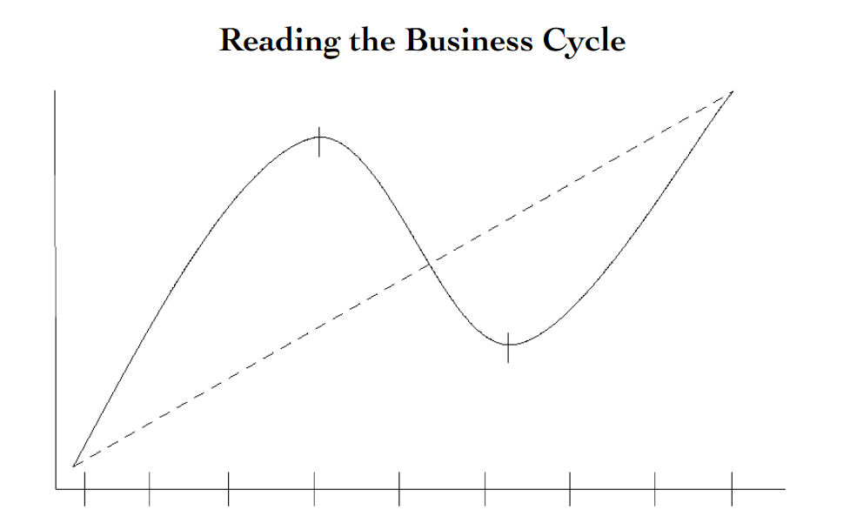

CUT HERE

Read each of the following headlines and place the proper letter next them that correspond with the business cycle.

E = Expansionary P = Peak C = Contractionary T = Trough

1. ________ The price of bread has increased 5% over the past three months.

2. ________ Interest rates at a low of 2% cause consumers to take out loans and buy homes.

3. ________ The sale of durable goods is down for the 5th consecutive month.

4. ________ Due to factory closures unemployment has risen to a five year highof 10%

5. ________ Due to increased consumer spending, the Federal Reserve raisesinterest rates to slow the economy down.

6. ________ The DOW Jones industrial average reaches an all-time high.

7. ________ GDP declines for four consecutive months, causing the Federal Reserve to lower interest rates.

8. ________ The unemployment rate is at 3.4%, a new 15 year low